**algorithm summary**

Find and modify a rule that does not count four at each digit.

**time-complexity**

O(lgn): Repeat for each number.

**Algorithm Details**

Input values can be divided into digits, i.e., 1399 can be divided into 1000+300+90+9, and the answer is to subtract sum the values considered of 4 at each digit from the input value. If so, a rule to figure out how many numbers each digit contains “4” can solve this problem.

For 100: If more than 4, the number containing 4 is 1, or 0.

For 101: If more than 4, the number containing 4 is 10+ (place value-1) *1, or as many as the number in decimal places.

For 102: If over 4, the number containing 4 is 102+ (place value-1) *19, or place value *19.

For 103: If 4 is exceeded, the number containing 4 is 103+ (place value-1) *271, or the number of place value *271.

Rules are visible from above 102. The number 19 is 1*9+10. Because there are 19 numbers in the decimal place, 19 errors (4 skipped) occur in the 100 digits except 400.

For 103 this principle's same application would result in 271=19*9+102, indicating the total number of cases, including 4 in the remaining instances except for 4000 units.

Figure 1 shows the application of algorithms to 1399.

<Figure 1> Application of Algorithm in 1399

The multiplying number (19, 271, …) is cn (n is digit) as shown in Formula 1.

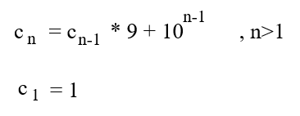<Formula 1>

an is the number of numbers containing four in the nth position, and b is the place number of nth digits, and an can be expressed as Formula 2.

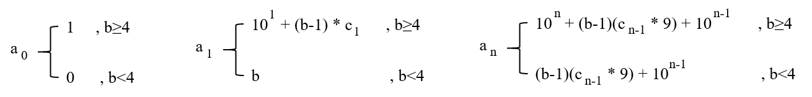

<Formula 2>

Discussion

After submitting it, I realized that it was simpler to do an operation that changed the decimal to decimal. I should think of more straightforward logic in the future. It is also likely that this flexible transformation of essence can be utilized for data communication based on network bandwidth.